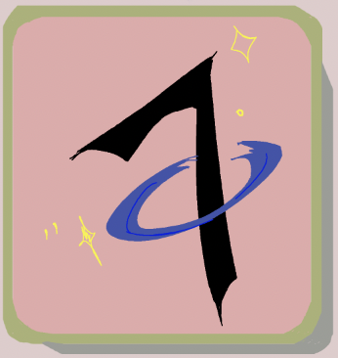

Orbit 7

**Project Description**

This game design document describes the details of our game which is a PC-exclusive 2D action-adventure game with a wide variety of puzzles and combat against enemies for the player and their allies to defeat and overcome.

The name of our game has been decided to be The Trials of Mo’varia.

1. *Characters*
2. *Story*
   1. *Theme*
3. *Story Progression*
4. *Gameplay*
   1. *Goal*
   2. *User Skills*
   3. *Game Mechanics*
   4. *Items & PowerUps*
   5. *Progression & Challenge*
   6. *Losing*
5. *Art style*
6. *Music & Sounds*
7. *Technical description*
8. *Marketing & Funding*
   1. *Demographics*
   2. *Platforms & Monetization*
   3. *Localization*
9. *Other ideas*

**1. Characters**

The player has four possible choices between what character they may play throughout the game, namely one of the members of the adventurer's guild.

**Julia Rivera** is the nature woman who has the ability to grow vines and plants to protect herself, as well as the power to grow vines to swing around on and attack enemies with. **Sammy Behemoth** is the short warrior yielding a huge axe and great strength

**Alice Sinclair** is the magic caster/magician that has the ability to summon and shoot fire and lightning at enemies from a distance.

**Jordan Serapis** is the shapeshifter with the ability to change forms and utilize his bandages for combat against enemies.

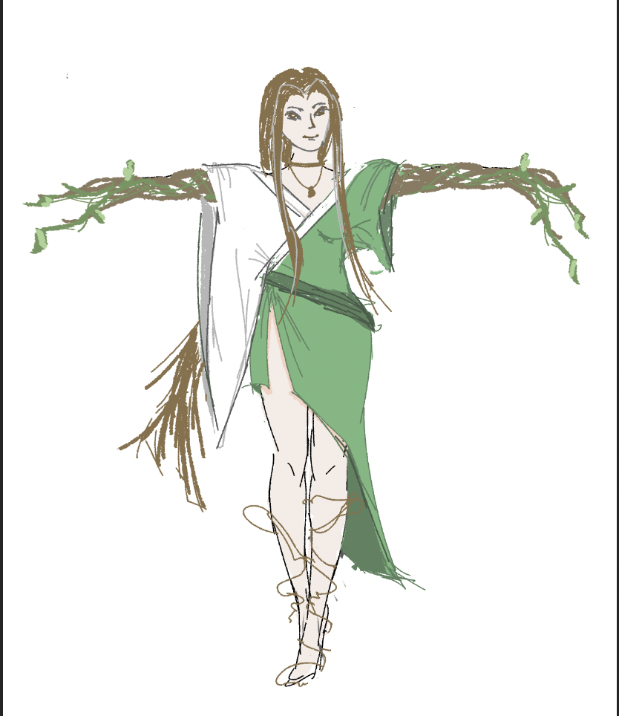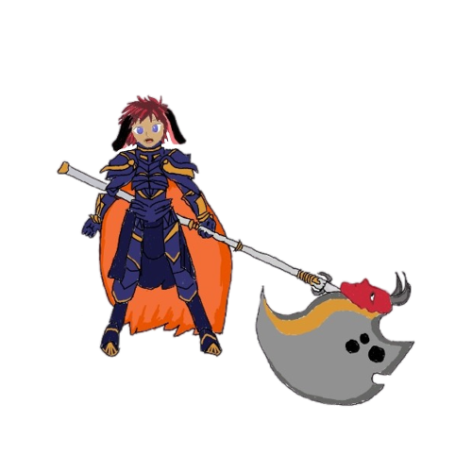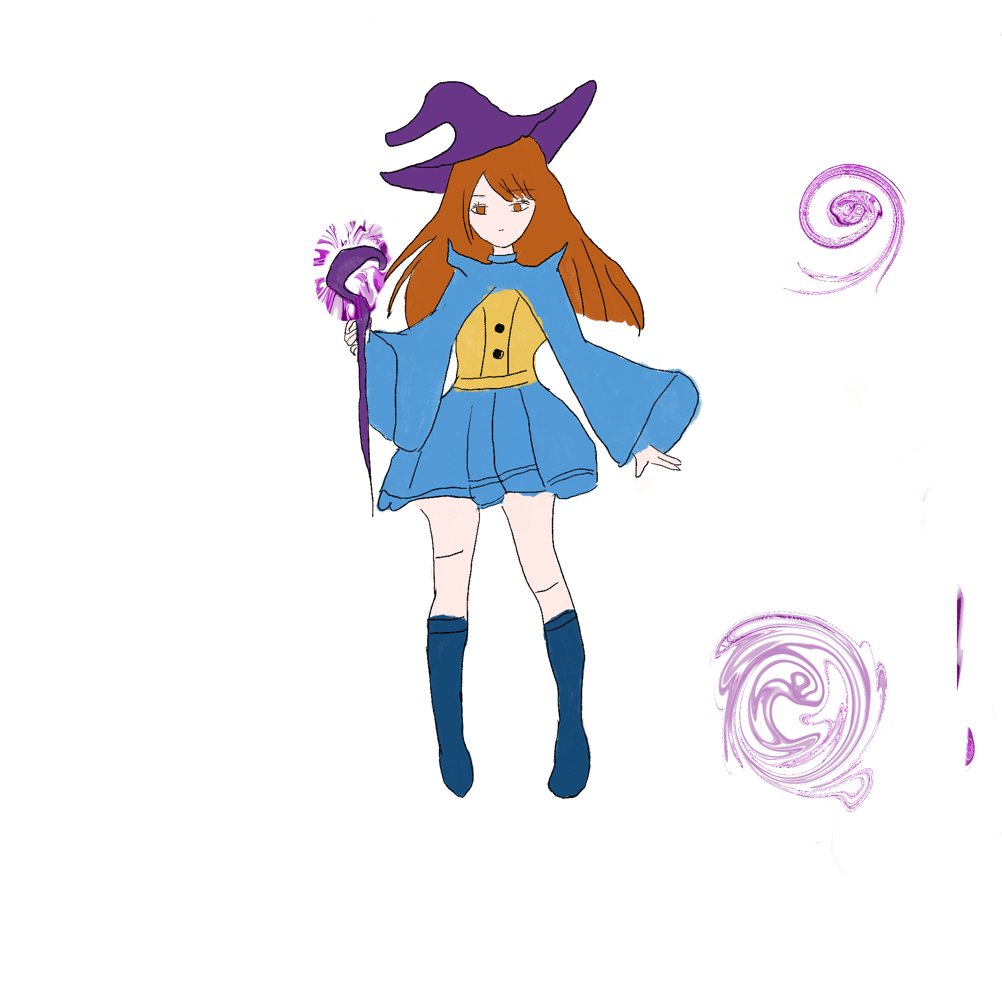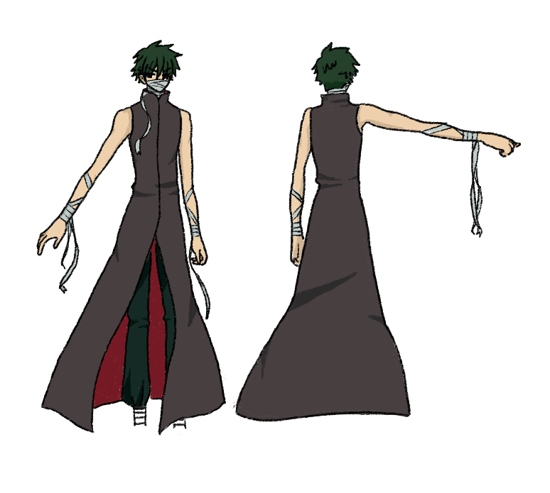

Main Boss:

**Lilith Lazabel** is the demon queen that took over Mo’varia against the townspeople’s wishes. She is determined to stay in control and in power.

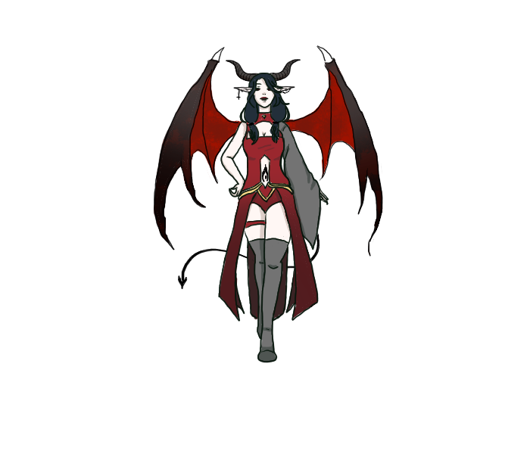

Commander Gallahad -Titan

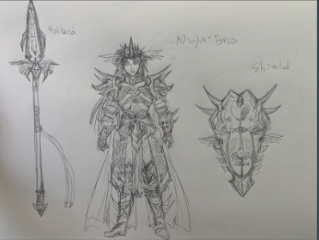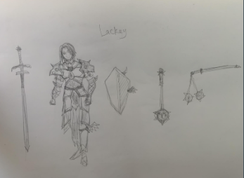

**2. Story**

The Kingdom of Mo’varia was once a peaceful town. However, a demon came and overtook the castle for her own. She’s taken over the kingdom, the army, and the town. The formerly peaceful kingdom turned into a nightmare.

You’re an adventurer in the adventurer’s guild, and one night, you went to the guild, and found like-minded individuals. You band together with these other adventurers to overthrow the demon queen and turn your once beautiful Kingdom back to the way it used to be.

You and your companions plan to break into the castle and defeat the Demon Queen to restore your kingdom to its former glory. To do this, you’ll have to solve puzzles, find keys and blueprints scattered throughout the town, and use these items to enter. While going through the town, the army’s knights are searching for you/planning to take you down and prevent you from completing your quest.

**2.1. Theme**

This game is about restoration, or rather returning the world to the way it was. With this in mind, this theme may generally give our game a darker theme. However, this game could have moments of happiness when levels and/or bosses are defeated. The story should generally get happier as the game progresses because we are rebuilding and restoring the kingdom in which you inhabit.

**3. Story Progression**

The game starts by first showing a brief intro cut-scene where your kingdom is taken over by the final boss.

Once the opening cutscene has finished, the player will begin a brief but informative tutorial on the basic mechanics of the game such as attacking enemies, interacting with puzzles, and switching between characters, where after completing the tutorial or skipping, the player can begin playing the game by first entering the level named **Town**. There you will need to defeat enemies and solve puzzles to obtain the first of the two required items, namely a key, to help your group open the castle gate and move to the next level. In the next level **Castle Courtyard**, where the player needs to solve more puzzles, fight enemies, and defeat the mini-boss, Commander Gallahad, to obtain the other item, namely a second key to unlock the main gate to the castle. Once both of the previous two items have been collected, the final level, **Castle,** will be unlockable with the use of the two previously collected items and allows the user to fight the boss. Additionally, before fighting the final boss an optional pathway is present for the player in the castle before fighting final bosslevel where if the player completes a few additional puzzles and defeats more enemies, gives them access to a choice between three items, namely a better weapon, increased health, or temporary defense for the player. Afterward, the final portion of the **Castle** level would take place in a throne room, where the player will fight the final boss of the game.

**4. Gameplay**

**4.1. Goals**

The overall (long-term goal) for this game is to defeat the final boss on the final level and acquire the necessary key items to get the boss. Our game’s gameplay (short-term) is to defeat enemies across levels, solve puzzles to advance, and acquire useful items to progress and advance to the next level.

**4.2. User Skills**

1. Swapping between characters
2. Puzzle-solving skills
3. Aiming capabilities
4. Team-utilization
5. Resource Collection
6. Memory
7. Synchronized button pressing

**4.3. Game Mechanics**

One of the major game mechanics we employed in this game is the ability to swap between the four main characters, at any point for any amount of time. As you wander around the other 3 characters will follow and occasionally attack enemies to aid the player in battle. Another mechanic is a health bar to limit how often the player can take damage from enemy attacks, which can be increased by items the player can gather and instantly use, and reduced by taking damage received from enemies and their attacks.

**4.4. Items and power-ups**

At the end of each level, namely, Town and Castle Grounds, the player will receive items necessary to progress and complete the game. For instance, finishing the Town level will give the user the main item of the key used to unlock the main gate for the final level. Additionally, the Castle Ground levels will also give the player the ability to unlock the gate for the final level. After the player chooses to go through an optional section in the castle level, the player will be given a choice between three power-ups, namely one that permanently increases the player's health, provides the player with stronger attacks, or gives the player repeated but temporary immunity from damage from enemies. Scattered across each level will be items that can permanently benefit the player such as increasing the players' health, or giving temporary benefits such as not being able to take damage for a small period of time.

**4.5. Progression and challenge**

The difficulty will advance by making the enemies both harder to damage and kill as well as them being slightly more abundant as the player goes further into the game. In addition, puzzles will become slightly more complex or require more thought in order to solve them. Progression in this game is made largely sequentially, where the player must first complete the town level and obtain the first key item, namely the first key for the front gate. Afterward, you tackle the Castle Grounds level, where you must clear a few puzzles and defeat both normal enemies and the mini-boss on this level, to obtain the second key. Once the player has both items, they may enter the final level where they can take on an optional route to gather beneficial items, or simply complete one or two complex puzzles while fighting a few more enemies before being able to fight the final boss.

**4.6. Losing**

The losing conditions occur when the player's health has been completely depleted after taking too much damage from enemies/bosses.

When the player actually does lose, a game over the screen will appear and force the user to restart their current level or exit the game if they so choose.

1. **Art style**

This game is going to be a 2D top-down game, with 2D anime-like sprites representing both the player and enemies. The characters will be chibi-styled like below, as opposed to the more detailed drawings above.

World Inspiration

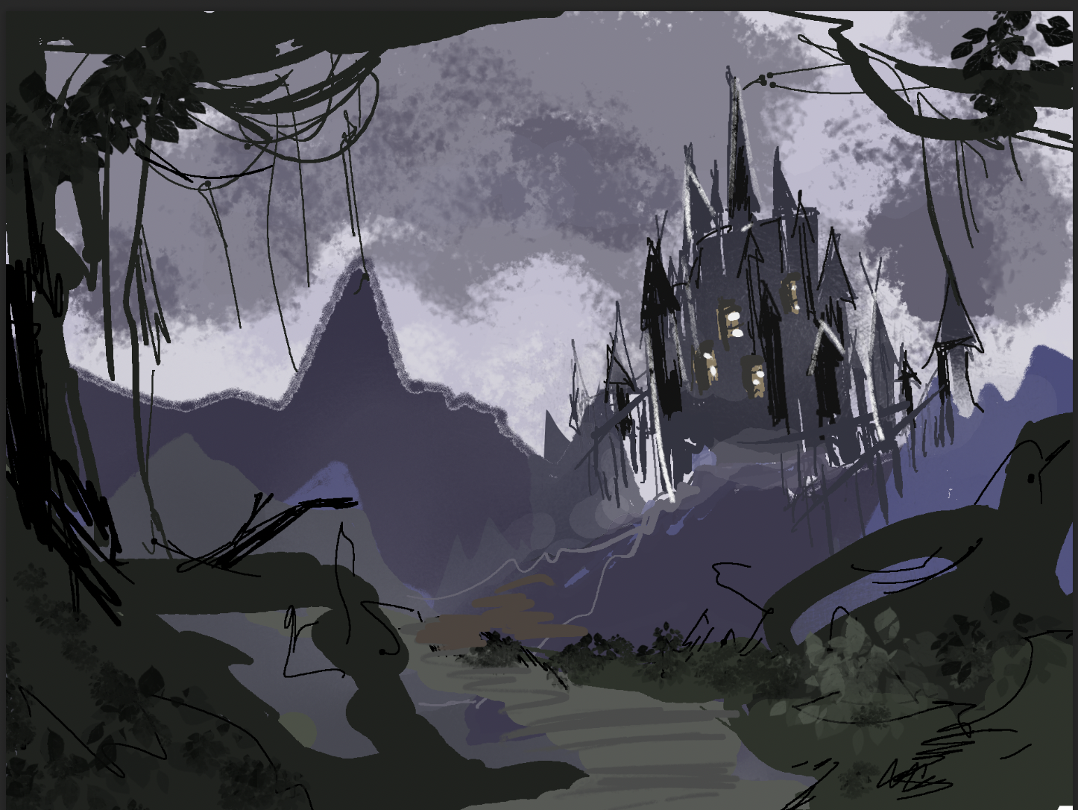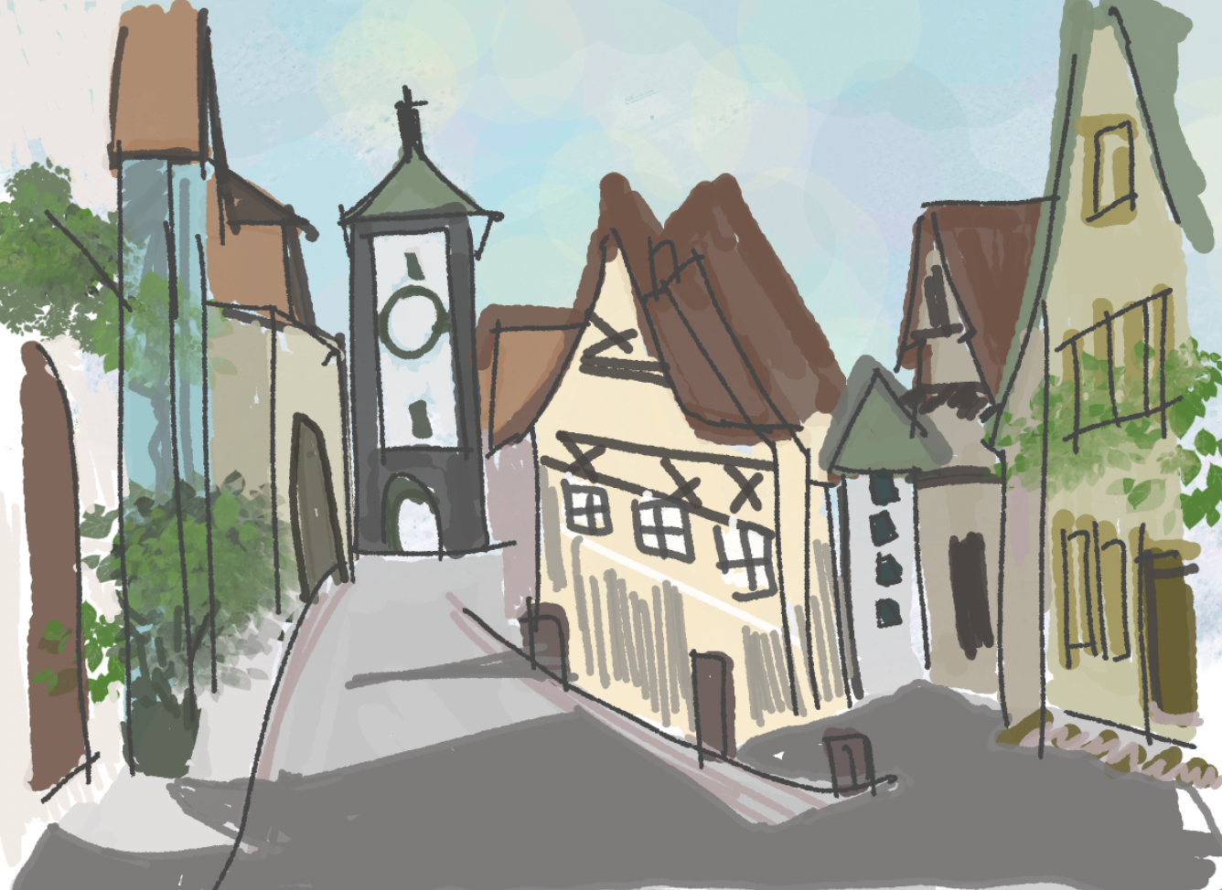

Characters

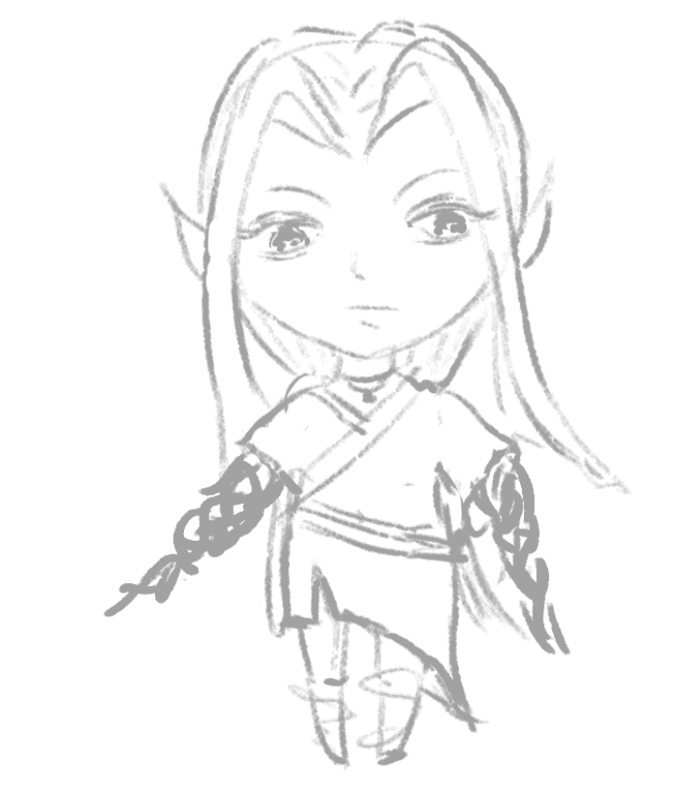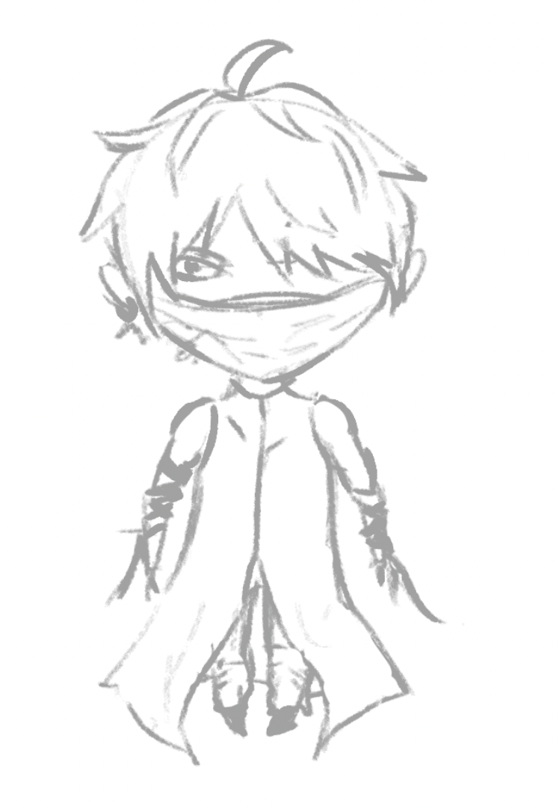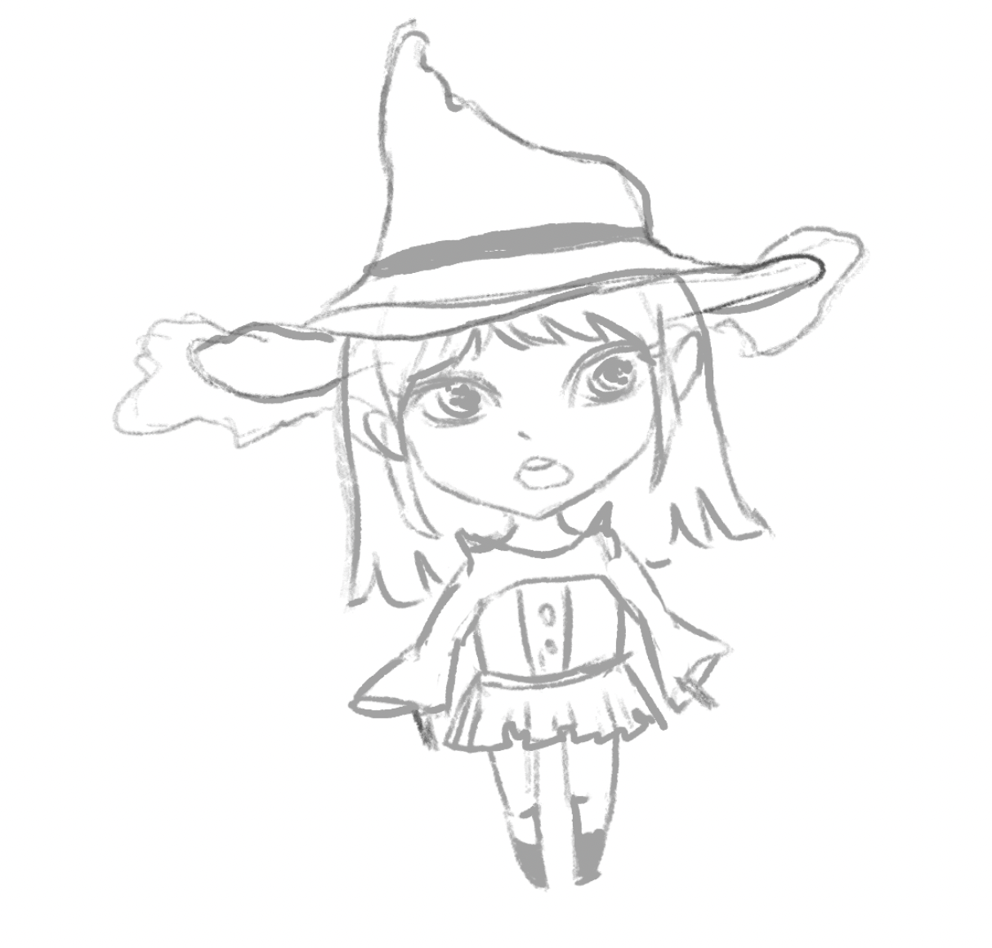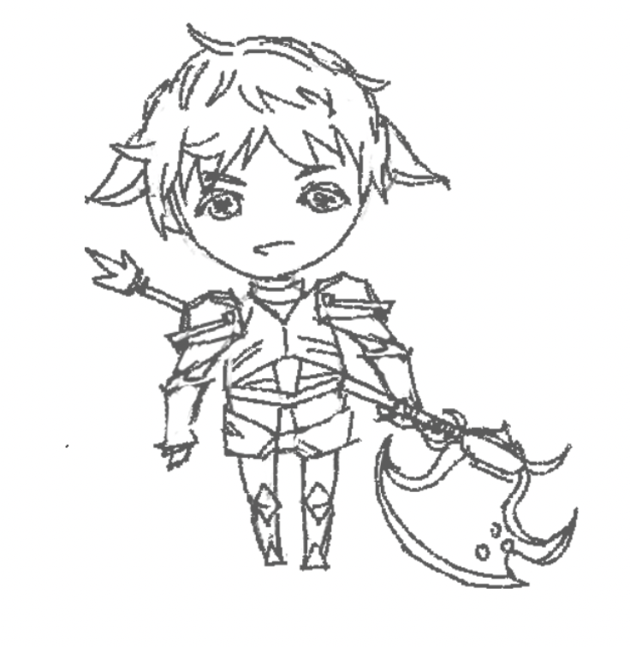

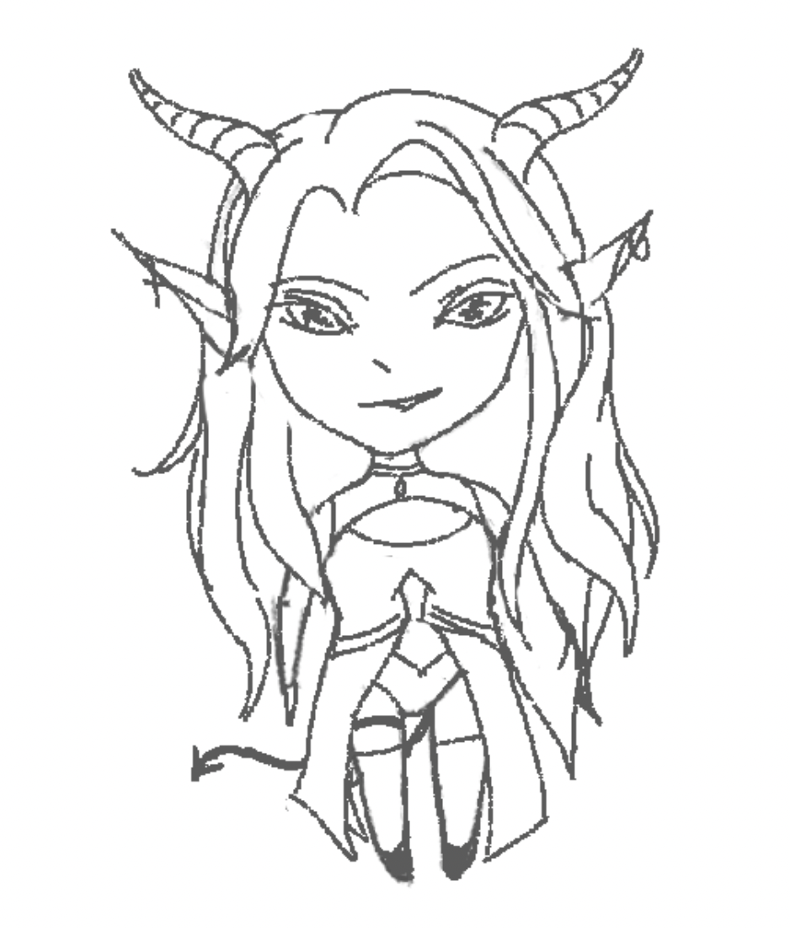

1. **Music and Sounds**

The in-game music we utilize for this game should utilize more somber and relaxing music, but that highlights the more saddening theme we are attempting to impart to the player.

After the completion of each level, the music should take a more joyful/happy tune because the player is both completing their goal, and restoring their kingdom.

When the player’s health is low and close to death, the music can be played a bit faster and higher in order to give an impression of alertness because you’re low on health.

When the player or their companions attack, quiet swiping sounds could be made every time they perform it.

1. **Technical description**

Initially and likely the game will remain as a standalone PC title. The only engine we will be using is only Unity 3D. For managing and storing our code and art assets Github will primarily be used. Discord and Microsoft Teams will be used for team communication between members.

1. **Marketing & Funding**

**8.1. Demographics**

Age: 14 to 40

Sex: Everyone

Focused mainly on mid-core players, as our game is not meant to be difficult but also not meant to be simple, in that someone can easily pick up and begin playing.

**8.2. Platforms & Monetization**

Probably throughout the creation of this game and its existence, we could monetize by having both a free version with ads and a paid version without ads, but our game will remain on Windows 10, with no serious intentions to move to other platforms. We will likely not have monetization in the game

**8.3. Localization**

The language we intend to support is English, but perhaps in the future other languages can be supported.

1. **Other ideas**

* Achievements
* Perhaps a multiplayer mode, which supports 2-4 players controlling the other characters following you that would otherwise follow you
* A detailed tutorial for the player to learn the controls and understand basic gameplay
* Possible level selection, allowing the player to choose what level they wish to play in any order they choose
* Time limit, meaning that you need to complete the level within a specified time period